1. 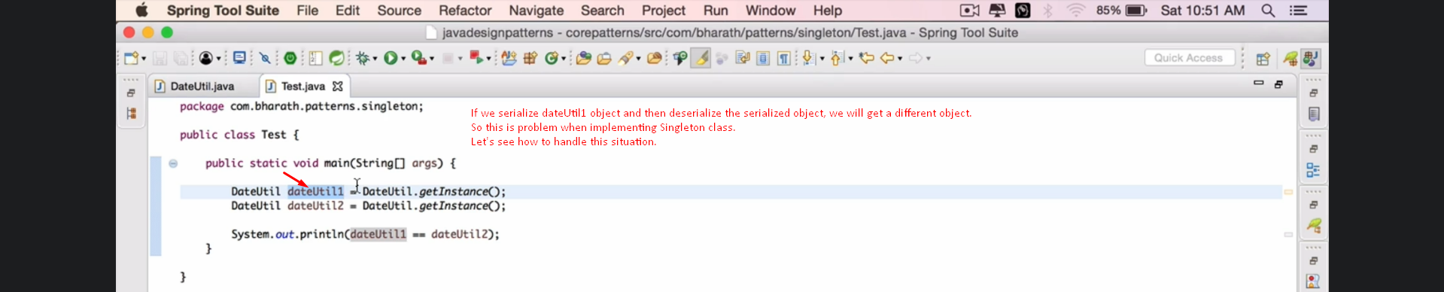If we serialize and deserialize, we will get a different instance.
2. Let’s create the problem first then in next lecture, we will see how to solve it.
3. 